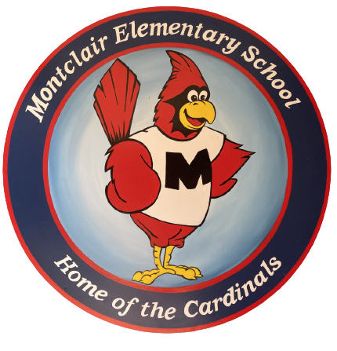
2026-2027
School Supply List
Second Grade

Welcome to second grade! We hope your summer was filled with fun. We are so excited to meet you and cannot wait for the school year to begin!

- 3 boxes of crayons
- 2 packs of glue sticks
- 2 packs of fine point black dry erase markers
- 2 packs of pre-sharpened pencils
- 1 pair of blunt tip scissors
- 1 plastic prong folder
- 2 composition notebooks (not spiral)
- Reusable water bottle

Donations welcome but not required:
- Tissues
- Pre-packaged snacks
- Any additional supplies from the list above
*Please label underlined items with your student’s name. All other items will be used for community classroom supplies.

