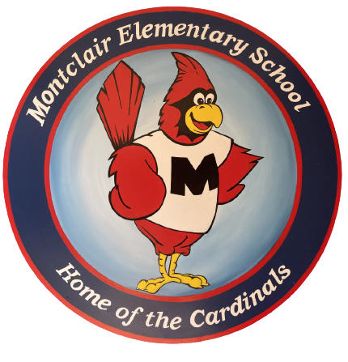
2026-2027
School Supply List
Kindergarten

Welcome to Kindergarten! We hope your summer is filled with fun. We are so excited to meet you and cannot wait for the school year to begin!

- 1 pair of child scissors (blunt tip)
- 3 boxes of crayons (24-count)
- 2 plastic poly folders- blue and yellow (not binders) with pockets and 3 prongs
- 3 glue sticks (small)
- 1 plastic pencil box (not a pouch)
- 3 packs of fine-tip dry erase markers (black only)
- 1 change of clothes in gallon-size baggie labeled with child's name
Boys- 1 box of sandwich-size baggies
Girls- 1 box of gallon baggies

Donations welcome but not required:
- Tissue boxes
- Dixie cups
- Paper towels
- Packs of colored copy paper
- Hand sanitizer
- Additional materials from the list above

