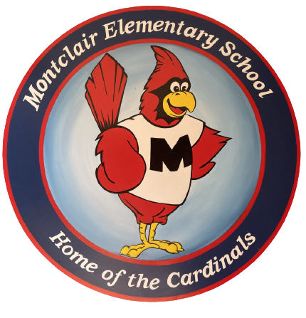
2026-2027
School Supply List
Fourth Grade

Welcome to fourth grade! We hope your summer is filled with fun. We are so excited to meet you and cannot wait for the school year to begin!

- 5 composition notebooks
- 4 folders with prongs (red, green, yellow)
- 1 pack dry erase markers (black preferred)
- 1 pack-colored pencils (no more than 16 count)
- 2 highlighters
- 1 pack of crayons (no more than 24 count)
- 1 pair of school scissors (6 inch)
- 1 pencil pouch
- 3 packs sharpened pencils
- 12 glue sticks

Donations welcome but not required:
- Boxes of tissues
- Sandwich-sized bags
- Hand sanitizer

