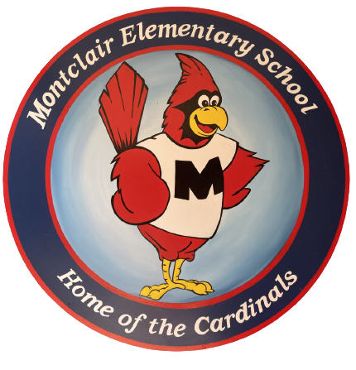
2026-2027
School Supply List
First Grade

Welcome to first grade! We hope your summer is filled with fun. We are so excited to meet you and cannot wait for the school year to begin!

- 2 packs of 24 pencils
- 3 packs of 6-count glue sticks (18 total)
- 3 boxes of crayons (24 count)
- 2 packs of 4 count fine tip black dry erase markers
- 1 marble composition book (wide ruled)
- 2 plastic poly folders (not binder) with pockets & 3 prongs
- 1 hard plastic pencil box
- 1 pair of child scissors (blunt tip)

Donations welcome but not required:
- Sandwich bags
- Quart bags
- Gallon bags
- 5 oz. bathroom cups
- Any of the items listed above

