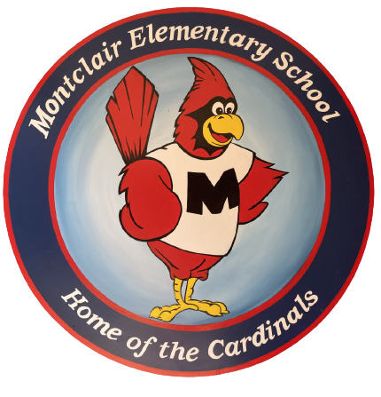
2026-2027
School Supply List
Fifth Grade

Welcome to fifth grade. We hope your summer is filled with fun. We are so excited to meet you and cannot wait for the school year to begin!

- 2 100-page count Composition Notebooks
- 2 Plastic two-pocket folders (green and yellow)
- 2 binders, 2 inch size
- 3 packs of 12 count sharpened #2 pencils (Not mechanical)
- 4 glue sticks
- 4 4-count dry erase markers (two sets black, two sets colored)
- 1 pack of 2-3 highlighters
- 1 2 pack scissors
- 1 binder pencil pouch (soft preferable, plastic breaks easily)

Donations welcome but not required:
- Sandwich and gallon bags
- Clorox Wipes
- Tissues
- Individually wrapped snacks

