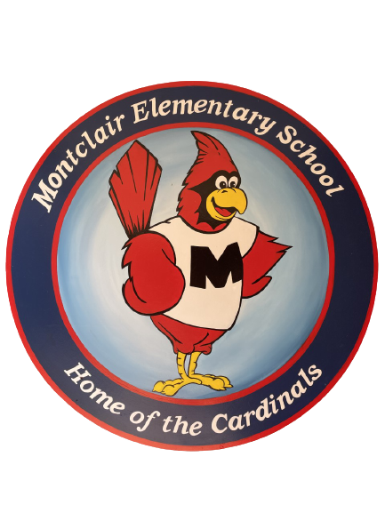
2024-2025
School Supply List

Multi Grade Classrooms
Mahiai, Spruill, Schoffstall

Welcome to our Self-Contained Autism Classrooms. We hope your summer is filled with fun and good books. We are so excited to meet you and cannot wait for the school year to begin!
- 1 box of crayons
- 12 glue sticks
- 1 pack fine tip dry erase markers
- 1 dry marker eraser
- 1 pack of pencils
- 1 pair of scissors
- 1 plastic pencil box
- 3 pocket folders

Donations welcome but not required:
- gallon size freezer bags
- quart size bags
- packs of baby wipes
- boxes of Kleenex
- bottles of hand sanitizer

