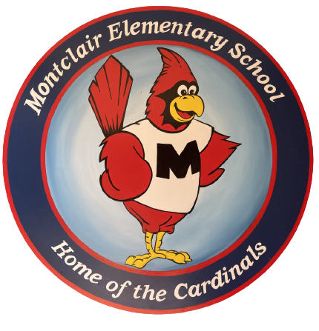
2023-2024
School Supply List
Second Grade

Welcome to second grade. We hope your summer is filled with fun and good books. We are so excited to meet you and cannot wait for the school year to begin!

- 3 boxes of crayons
- 2 packs of glue sticks
- 1 pair of blunt tip scissors
- 2 plastic prong folders
- 2 packs of fine point black dry erase markers
- 2 packs of pre-sharpened pencils
- 4 composition notebooks (not spiral)
1 black, 1 green, & 2 colors of your choice
- Plastic Pencil Box

- Donations:
- Gallon Sized Bags
- Sandwich size bags
- Tissues
- Any additional supplies from the list above

